RECIPE
Spicy Tomato Cream Pasta
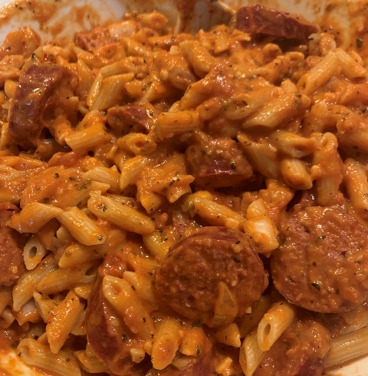
Ready in 15 minutes
Serves 4 people
Ingredients
- 1 pound Four Families Penne Pasta
- 1 tbsp olive oil
- 1 small onion diced
- 1/2 tsp dried basil
- 1/ 4 to 1/2 tsp. crushed red pepper flakes
- 1 (24 ounce) jar spaghetti sauce
- ½ cup heavy cream
- 1/4 tsp salt
- 1/4 tsp black pepper
- 1 pound package sausage cooked (we use deer sausage)

Preparation
- Heat oil in a large saucepan over medium heat. Add onion and cook 3 minutes.
- Add garlic, basil and red pepper flakes and cook 1 minute.
- Add spaghetti sauce, heavy cream, salt & pepper. Simmer for 10 minutes, or until thickened to your liking.
- Cook pasta according to package directions. Drain and mix together with sauce.
- Add cooked sausage.

