RECIPE
Penne with Chicken and Vegetables
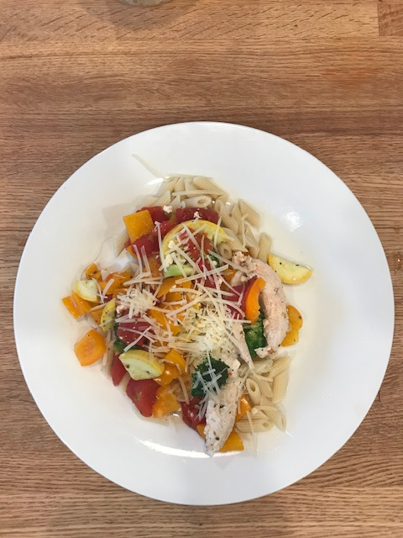
Ready in 15 minutes
Serves 6 people
Ingredients
- 9 ounces Four Families Penne Pasta
- 1 pound boneless skinless chicken breast cut into 1 inch strips
- 1 tbsp olive oil
- 2 cups broccoli florets
- 2 medium red bell peppers, sliced into thin strips
- 2 medium yellow squash, sliced
- 1 14 ounce can no salt added sliced tomatoes, juice drained
- 1/4 cup white wine
- 1/2 tsp basil
- 1/2 tsp dried oregano
- 1/4 tsp salt (optional)
- 1/4 tsp black pepper
- 1/4 cup freshly grated parmesan cheese

Preparation
- Cook pasta according to package directions omitting salt.
- Coat a large nonstick skillet with cooking spray. Over medium-high heat, cook chicken strips for about 3-5 minutes or until done. Remove from pan and set aside.
- Add olive oil to pan. Sauté’ broccoli, red, peppers, and squash for 3-4 minutes. Add tomatoes, wine, herbs, salt, and pepper. Cook for 5-7 more minutes.
- Toss chicken and vegetable mixture with drained, cooked penne pasta. Sprinkle with Parmesan cheese.

